PROJECT DOCUMENTATION
Power BI
Executive Reporting & Dashboards for Network Request Automation
PROJECT
Automated Network Request Management

Date
Team ID
Project Name | Automated Network Request Management
Maximum Marks

1. Introduction
While ServiceNow executes and tracks the automated network request workflow, Power BI is used to deliver consolidated, executive-level reporting on the health and performance of the process. This gives IT leadership real-time visibility into request volumes, SLA compliance, and change outcomes — supporting the project's goal of ensuring real-time updates across stakeholders.

2. Objective
- Provide a single, real-time view of network request volume, status, and SLA performance.
- Track automation effectiveness, including the proportion of requests fulfilled without manual intervention.
- Support data-driven decisions on staffing, process improvement, and change governance.
- Enable self-service reporting so stakeholders are not dependent on manually built status reports.

3. Data Integration
Power BI connects to ServiceNow using the native ServiceNow connector (OData / REST API), pulling data from key tables including the network request table, change request table, CMDB, and SLA definitions. Scheduled refreshes keep dashboards current without manual data extraction.

4. Executive Dashboard
The dashboard below illustrates the kind of consolidated view delivered to stakeholders: key performance indicators at a glance, monthly volume trends, and a breakdown of requests by type.
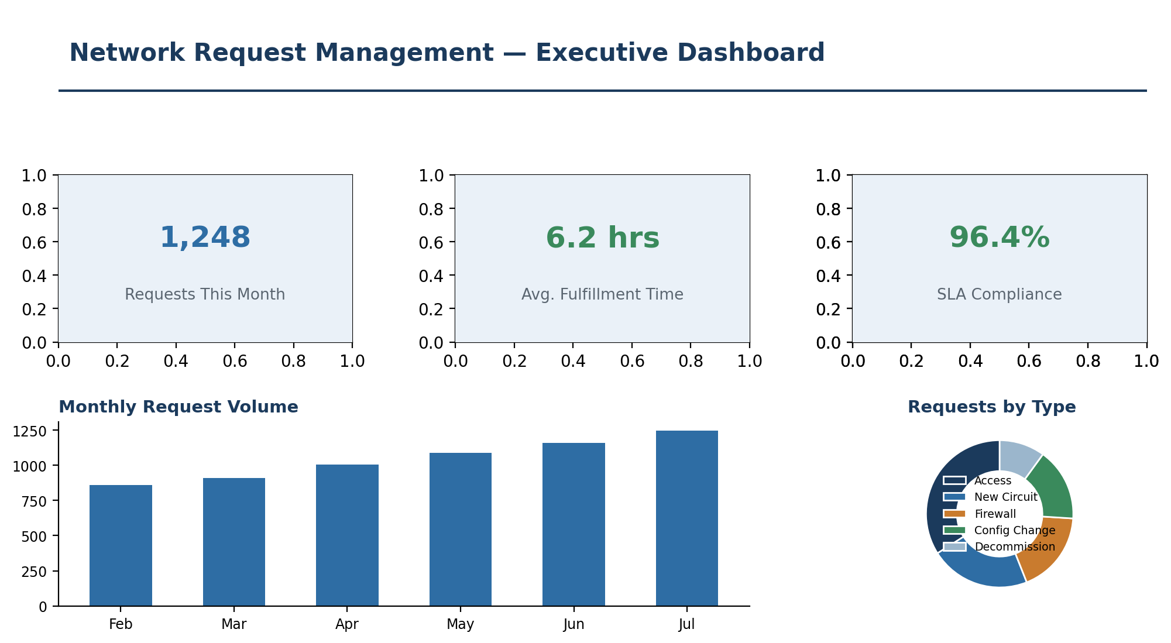
Figure 1: Sample Power BI executive dashboard for network request management

5. Key Metrics Tracked
KPI | Description
Total requests | Volume of network requests submitted over a selected period
Average fulfillment time | Time from submission to completion, tracked against SLA targets
SLA compliance rate | Percentage of requests fulfilled within their defined SLA
Auto-approval rate | Percentage of requests fulfilled without manual approval
Requests by type | Distribution across categories such as access, circuit, firewall, and configuration changes
Change success rate | Percentage of automated changes completed without rollback or failure

6. Report Structure

6.1 Executive Summary Page
High-level KPI cards and trend charts intended for leadership review, refreshed automatically from ServiceNow.

6.2 Operational Detail Page
Drill-down views for the network operations team to identify bottlenecks by request type, region, or approval stage.

6.3 Audit & Compliance Page
A record-level view supporting audit needs, showing which requests were auto-approved, which required manual review, and the associated change records.

7. Benefits to the Project
- Real-time visibility replaces manually compiled status reports, directly supporting the project's real-time update objective.
- Leadership can quickly identify whether automation targets (fulfillment speed, SLA compliance) are being met.
- Trend analysis supports continuous improvement of the automated workflow.
- Audit-ready reporting reduces effort during compliance reviews.

8. Conclusion
Power BI complements the ServiceNow automation by turning operational data into actionable, real-time reporting. This ensures the Automated Network Request Management project's outcomes are visible and measurable, reinforcing accountability and continuous improvement.

